**Alternatives Homework**

**Problem 2-4:**

1. There are three main processes for separating solids from gas:
2. **Cyclone and Inertial Separations**

This method utilizes high gas velocities and centrifugal force to remove dust from air. In short, the air is pushed into a conical chamber that forces it to spin or “cyclone” around. The centrifugal forces affect the smaller gas molecules more and push them out and up through the top, while the heavier solid particles drop down through the bottom.

1. **Baghouse Collections**

A baghouse collection mechanism is an advanced air filter. The air is forced into a rectangular housing full of cloth bags through which the pressurized air flows. The bags are routinely shaken to allow dust to dislodge from the cloth and drop to the bottom of the bag. This is a continuous process but requires periodic changing of the bags to clean.

1. **Wet Scrubbers**

Wet scrubbers were designed to get over the main design flaw of cyclones and baghouse collectors – that dust particles are frequently swept back into the exiting stream – they are not as efficient. A wet scrubber is a unit that utilizes water to trap dust in air and remove it. Air is passed through a cylindrical manifold. In the middle of this manifold is a spray nozzle through which water is atomized. This water binds to the dust particles and falls to bottom where it is collected and pulled out.

1. Some popular methods for separating solid-solid systems are leaching (chemical), sieving, and magnetic separation:
2. **Leaching**

In chemistry, leaching is the process by which one can dissolve a substance into some solvent (organic or inorganic) and extract the undissolved solid particles. Substance A dissolves, and substance B, which is undissolved, can be extracted. This process is very thorough but requires a proper solvent to enact.

1. **Sieving**

A sieve is a device for separating wanted elements from unwanted elements. It acts as a strainer and the larger particles will stay behind, while smaller particles will fall through. This is a great process because it scales up nicely and is extremely cheap. However, it only works If the solids to be separated are different sizes.

1. **Magnetic Separation**

This method is just as it sounds. One can take advantage of the magnetic properties of materials to pull them out of bulk material piles. This process is great because it can be run continuously and is very selective, however, the material to be separated must be magnetic.

1. Some popular methods for separating solid-liquid systems are filtration, drying, and centrifugation:
2. **Filtration**

This common technique is used to pull small molecules out of liquid phase. Membrane filtration is when a solid-infused liquid is passed through a porous membrane. While the liquid passes through, the solids stay behind. The pore size dictates what sized solids will stay behind. This is a great way to have a continuous process, but sometimes process throughput can be decreased.

1. **Drying**

Drying is a process in which liquids are evaporated off solids to separate them. The liquid in question usually is water in this case, but it can vary. This process is a nice continuous process that can provide a high throughput and scales nicely. However, energy requirements to evaporate the liquid can become very large.

1. **Centrifugation**

Centrifugation utilizes the effect of bouncy, and g-forces to separate solids and liquids. The solid-liquid system is subjected to rapid spinning and g-forces. The solid particles in solution will fall out of solution and be pushed to the bottom of the system. Afterwards, the liquid phase can be separated.

**Problem 10-1:**

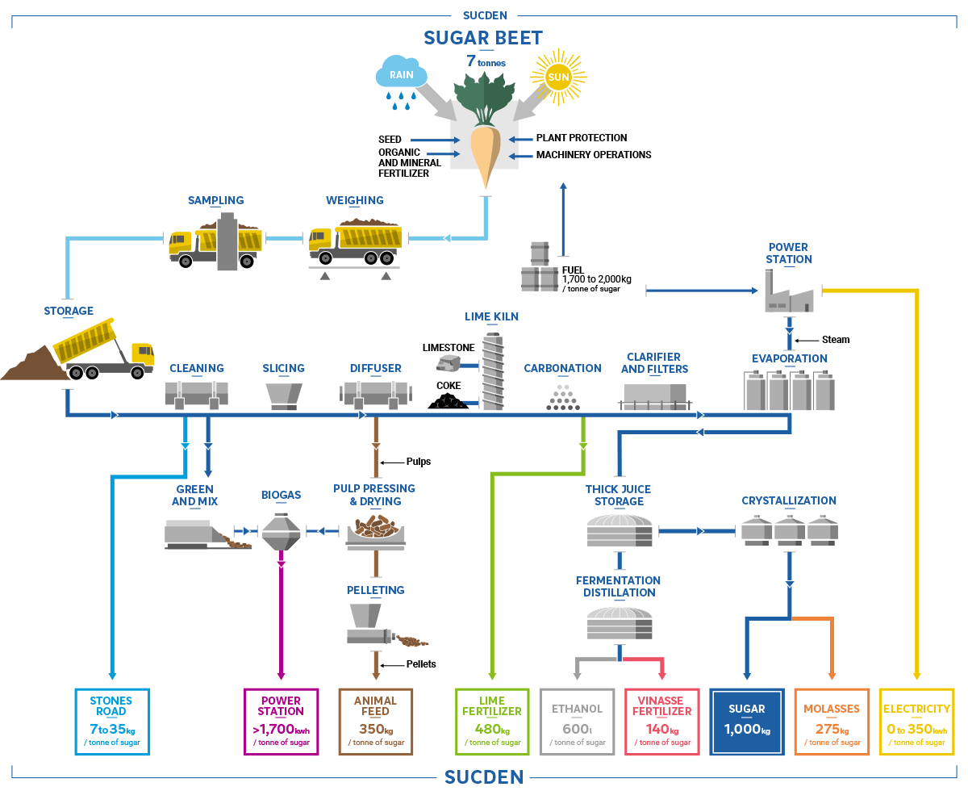

|  |  |  |
| --- | --- | --- |
| **Item/Unite Op** | **Function** | **Relation to Overall Goal** |
| Washing | Clean beets | * Prevent contamination * Prep for slicing |
| Slicing | Cut beets into smaller sections | * Process beets and allow for better downstream processing * Increase surface area to volume ratio to expedite diffusion * Better handle product on the line |
| Diffusion | Extract sugar from beets | * This isolates the sugar from the beets * Properly takes solid-solid phase and puts it into a solid-liquid phase |
| Filtration | Remove unwanted solids | * Remove contaminants * Purify product even more for downstream processing |
| Evaporation | Separates the solid-liquid phase | * This removes the liquid from the product to produce pure sugar * Final step in process |

**Problem 10-2:**

Three large alternatives to ice-crystal desalination are evaporation, reverse osmosis, and electrodialysis. There are many pros and cons to these methods with respect to cost, efficiency, throughput, and quality. The table below summarizes these alternatives and their analysis’.

|  |  |  |
| --- | --- | --- |
| **Alternative** | **Pros** | **Cons** |
| Evaporation | * High throughput * Continuous process | * Requires a substantial amount of energy input. |
| Reverse Osmosis | * High purity | * Expensive * Low throughput |
| Electrodialysis | * High purity * Clean | * Expensive * Low Throughput |

**Problem 10-3:**

**a.)**

We know that the energy for the evaporator is equal to:

$$Q_{e} = {\dot{m}}_{R}(h_{1} - h_{4})$$

In addition, the compressor energy balance amounts to:

$$W_{c} = {\dot{m}}_{R}(h_{2} - h_{1})$$

We can rearrange these equations to sole for the compressor work required:

$$W_{c} = \frac{Q_{e}}{(h_{1} - h_{4})}(h_{2} - h_{1})$$

Or

$$W_{c} = Q_{e}\frac{(h_{2} - h_{1})}{(h_{1} - h_{4})}$$

Given the temperatures, we know that the enthalpies are:

h1 = 610 BTU/lb

h2 = 750 BTU/lb

h4 = 40 BTU/lb

Qe = 1.5 MJ/s = 1421.73 BTU/s

Thus, the work can be calculated:

Wc = (1421.73 BTU/s)*(750 BTU/lb – 610 BTU/lb)/(610 BTU/lb – 40 BTU/lb) = 349.197 BTU/s

Thus, our duty becomes:

M(h2 – h4)= 710 BTU/lb * 2.17 lb/s = 1771 BTU/s

**b.)**

A first improvement could be to reduce the amount of refrigerant required in the process. We could do this by changing our process such that the amount of heat required too be pulled out is less.

The enthalpies stay the same, but the mass requirement can be decreased by 25%.

Work is now: 266 BTU/s

Another improvement could be increasing the temperature required for the evaporator to function. We can increase the evaporator temperature from -5 to 20 0F.

This changes our enthalpies, h4 now becomes 60 BTU/lb.

Thus, our new compressor work is 361.89 BTU/s

**Assigned Problem:**

**A.)**

$$W_{c} = \frac{Q_{e}}{(h_{1} - h_{4})}(h_{2} - h_{1})$$

Or

$$W_{c} =Q_{e}\frac{\left(h_{2}-h_{1}\right)}{\left(h_{1}-h_{4}\right)}$$